# Business Expansion

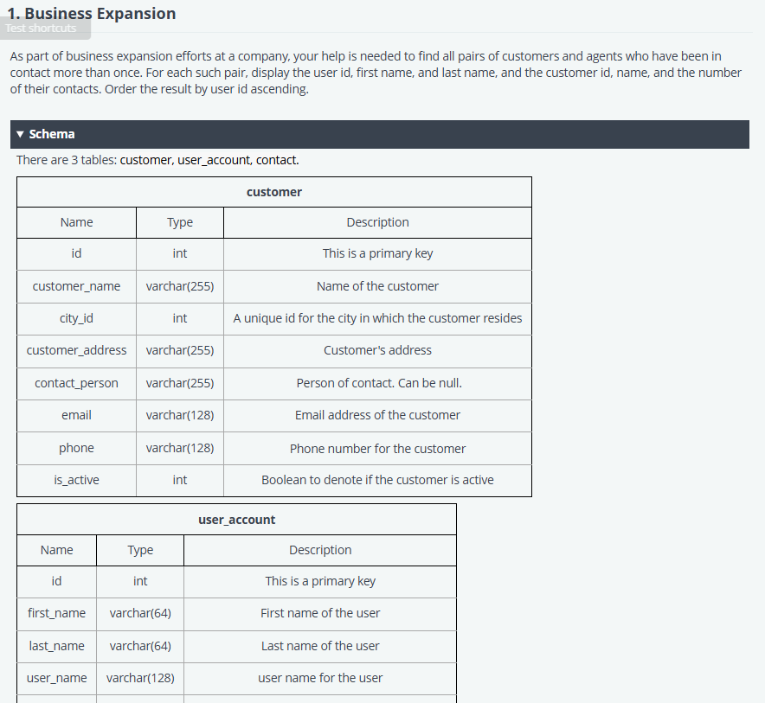

/*

Enter your query below.

Please append a semicolon ";" at the end of the query

*/

SELECT

     contact.user_account_id,

     user_account.first_name,

     user_account.last_name,

     contact.customer_id,

     customer.customer_name,

     count(*) as numbers

FROM

     contact as contact

JOIN

     user_account as user_account

ON

     contact.user_account_id = user_account.id

JOIN

     customer as customer

ON

     contact.customer_id = customer.id

WHERE (contact.user_account_id, contact.customer_id) IN (

    SELECT user_account_id, customer_id FROM contact GROUP BY user_account_id, customer_id HAVING count(*) > 1

)

GROUP BY

    contact.user_account_id ,contact.customer_id, user_account.first_name, user_account.last_name, customer.customer_name;

# Customer Spending

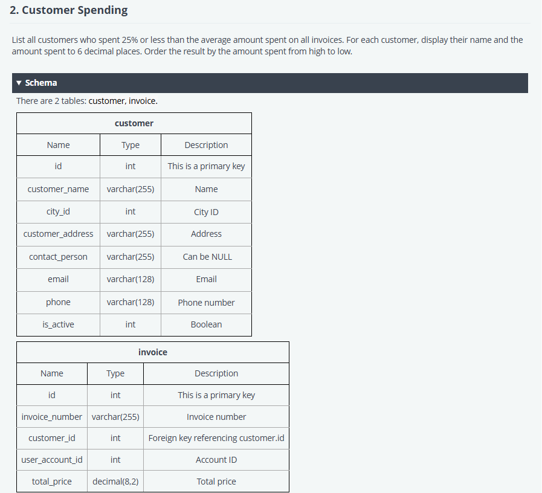

/*

Enter your query below.

Please append a semicolon ";" at the end of the query

*/

WITH avg_spending AS (

    SELECT AVG(total_price) AS avg_amount

    FROM invoice

),

customer_spending AS (

    SELECT

        c.customer_name,

        SUM(i.total_price) AS total_spent

    FROM customer c

    JOIN invoice i ON c.id = i.customer_id

    GROUP BY c.id, c.customer_name

)

SELECT cs.customer_name, FORMAT(cs.total_spent, 6) AS total_spent  -- Use FORMAT() for 6 decimal places

FROM customer_spending cs, avg_spending avg

WHERE cs.total_spent <= 0.25 * avg.avg_amount

ORDER BY cs.total_spent DESC;